12-9-2022

**Indigo Team Milestone 3**

**Team Members**

Joshua Aguilar

Sam Crandall

Kadar Gayle

Jacob Ives

Jeff Pedersen

Our Group ended up with 5 reports in total.

**Delivery Arrival Report**

This report is to address the question of if the suppliers are delivering on time or not.

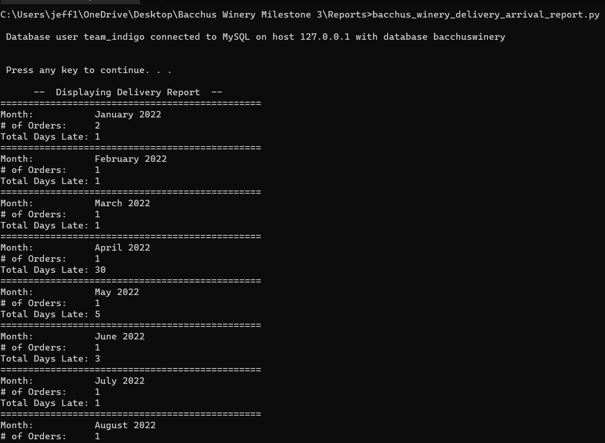

**Monthly Sales Report**

This report breaks down the total sales of each of the 4 types of wine by month.

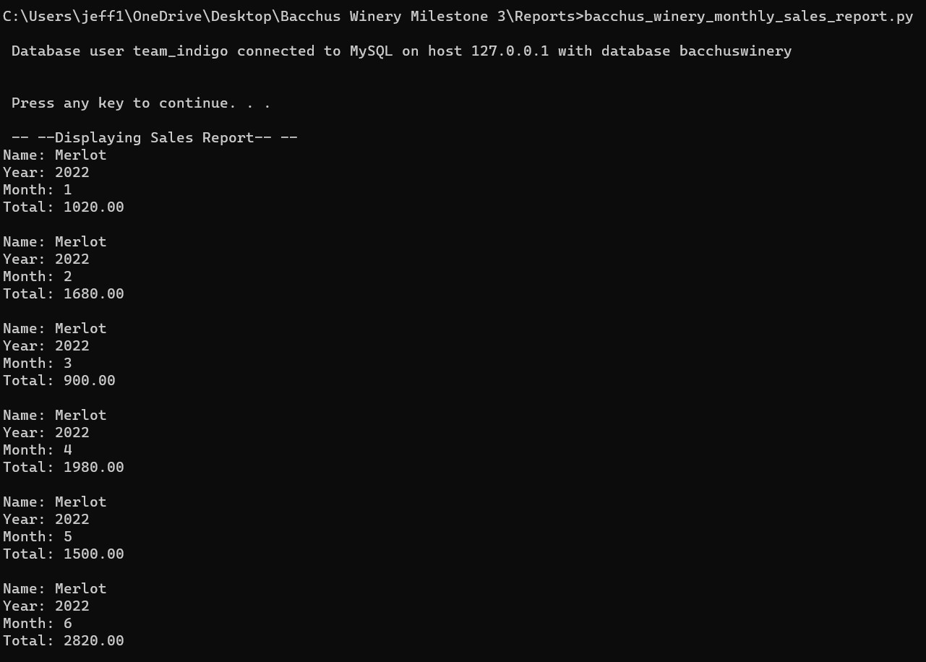

**Wine Sales Report**

In this report the YTD total bottles sold is listed per wine.

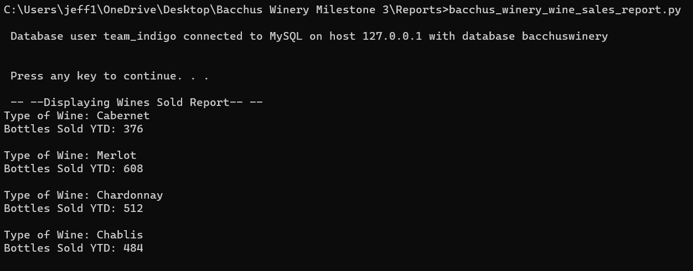

**Distributor Report**

This report details which distributors carry which wines.

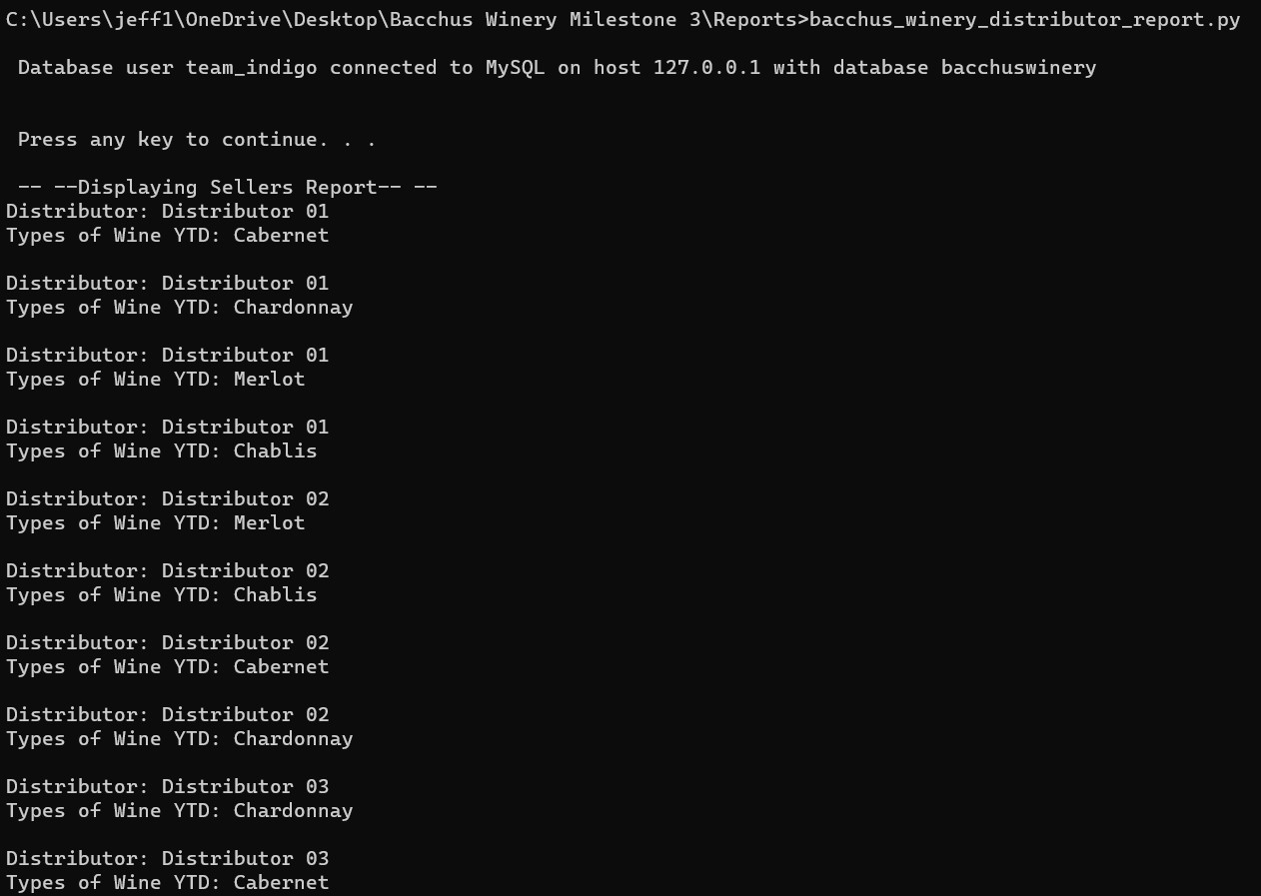

**Hours Report**

In this report the hours worked during the current week as well as the hours worked YTD are detailed for each employee.

